ID: 180917

Course: Android Application Development II

Date: March 06, 2019

Class Summary

In the class on the date above we learnt about the Android sound operations through the use of a class called SoundPool. The SoundPool class provides the ability to controlling how many sounds can play concurrently, this is crucial because it prevents the app from crashing if too many sounds are playing simultaneously through the use of a limit. The audio stream is a required parameter that is used to specify what category of audio is being played. Examples of audio stream categories include alarms, notifications and in-app audio. Each audio stream’s volume can be controlled independently.

For the classwork we were required to:

1. Try to build, run, and understand the app

The task above was completed successfully

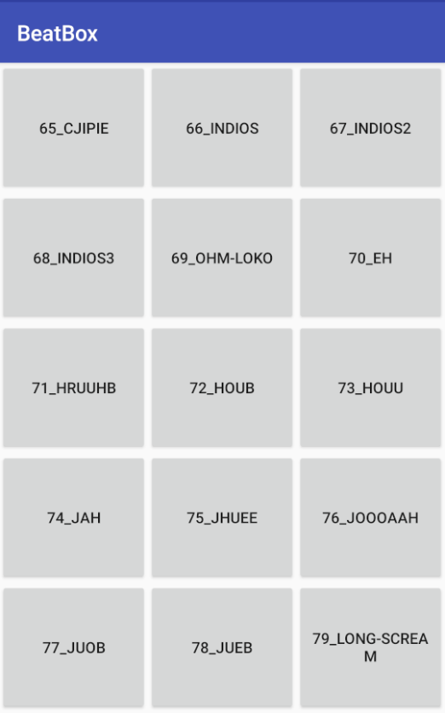

The running application is shown above. Upon tapping on each tile a different sound is played, with at most five sounds playing simualtaniously.

1. Add a playback speed control to the app, e.g. a SeekBar or TextBox, ref. play(…) function

A seekbar was inserted to control the playback speed

1. Play some music in the background, ref. MediaPlayer class
2. Make a music player app, ref. MediaController widget